Maya Projection To Texture Script Instructions

Version 1.1

1. Install proj2tex.py in your maya scripts directory

2. Set up shelf button with the following Python commands:

* import proj2tex
* import importlib
* importlib.reload(proj2tex)
* proj2tex.run()

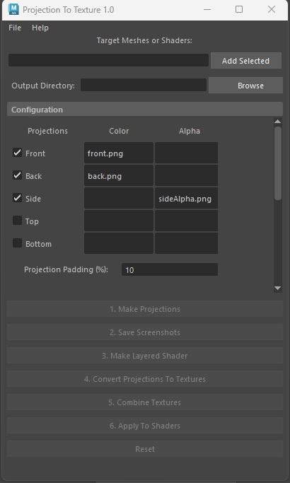

3. In the first field "Target Meshes or Shaders", add all the meshes and shaders (names delimited by commas) that you wish to include in the projection baking process. You can use the "Add Selected" button to add the objects that are currently selected in the viewport.

4. In the Configuration panel you can configure various properties related to the orientation of the projections and how they are composited. See the Appendix of this document for details of what each option does.

5. Run "Make Projections" to set up projections for the mesh

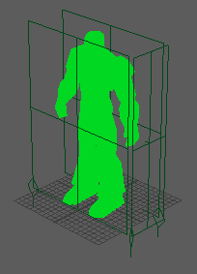

6. Run "Save Screenshots" to save out cropped screenshots for each of the projections, they will be written to the path specified in the XML configuration

| Front | Side | Back |
| --- | --- | --- |

7. Overlay desired visuals onto the screenshots (note in the current configuration we are using the Side projection to define the alpha of the Front projection).

| Front | Side | Back |
| --- | --- | --- |

8. Run "Make Layered Shader" to project the visuals onto the mesh.

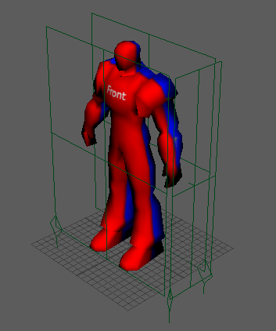

9. Run "Convert Projections To Textures" to convert the individual projections into textures for the target mesh. The converted textures will appear in the same folder as "X_baked.png".

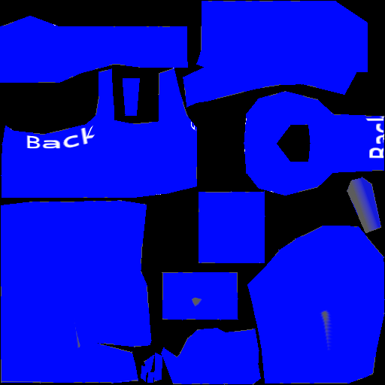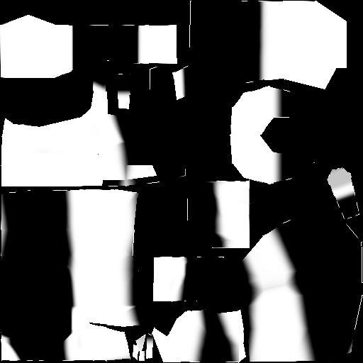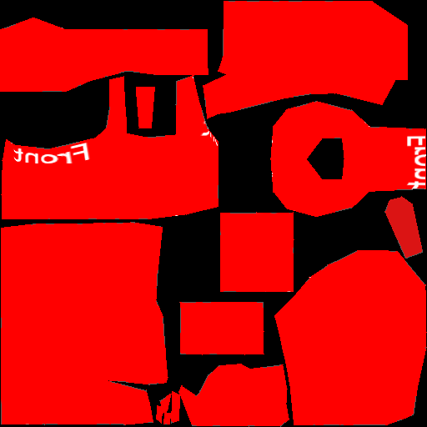

10. Run "Combine Textures" to composite the textures together.

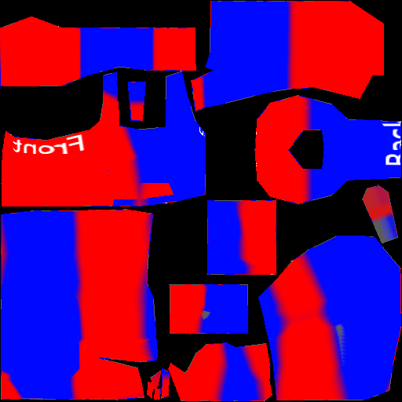

11. Run "Apply to Shaders" to apply the composited textures to the target shaders and meshes.

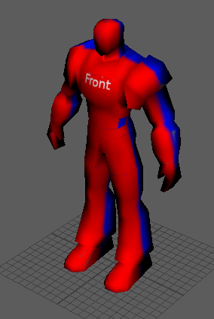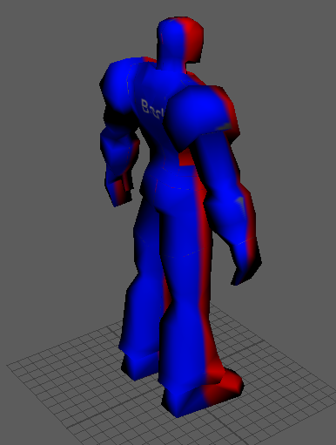

Appendix

# Configuration Options

## Projections

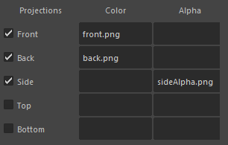

* This section defines which projections are enabled, there are 5 possible orientations to choose from.
* For each you specify the file name of the image to produce for the screenshot for that projection (you can produce up to two images, for Color and Alpha)

## Projection Padding



* This adds an empty frame around the target meshes in the projection. The value is specified as a percentage of the bounding box size (default 10%).

## Layers

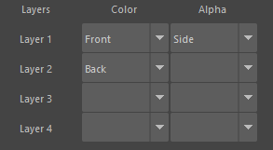

* This section defines how to composite the projections. You can define up to 4 layers, Layer 1 will be on top, Layer 4 will be on the bottom.
* For each layer you define which projection to use for Color, and which to use for Alpha. The default configuration (used in the running example of these instructions) has 2 layers: the first uses the Front for the color of the first layer and Side for the alpha; the second uses the Back projection for the color of the second layer.

## Other Options

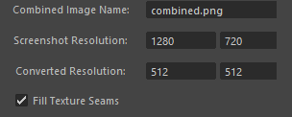

* Combined Image Name: The name and image format of the final combined texture. Note that this will become "combined_<geometry name>.png" to handle the case of multiple meshes with different UVs.
* Screenshot Resolution: Resolution of the viewport screenshot to take (note that the final cropped screenshot will be smaller than this).
* Converted Resolution: Desired resolution of each of the converted textures and final combined texture.
* Fill Texture Seams: Enables the "Fill Texture Seams" option for Maya's texture baking, which will give smoother seam transitions.

## 

## Installation on macOS

macOS requires some additional installation steps for the script to run. After installing the script to your Maya script's directory, do the following:

1. Install MacPorts: <https://www.macports.org/install.php>
2. Install ImageMagick via the command "sudo port install ImageMagick"